COINS- Aurelian-270-275 AD-, Sol holding globe- Sear5 11564v

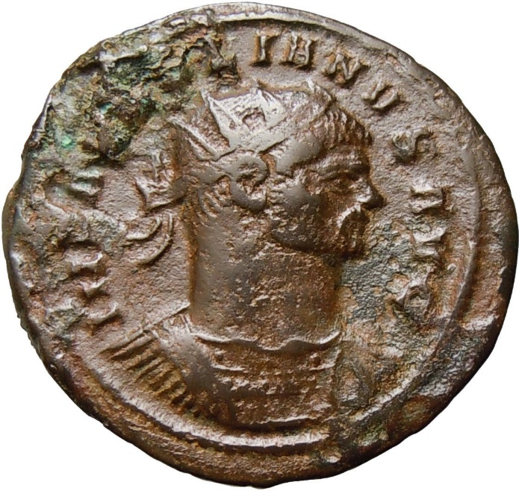 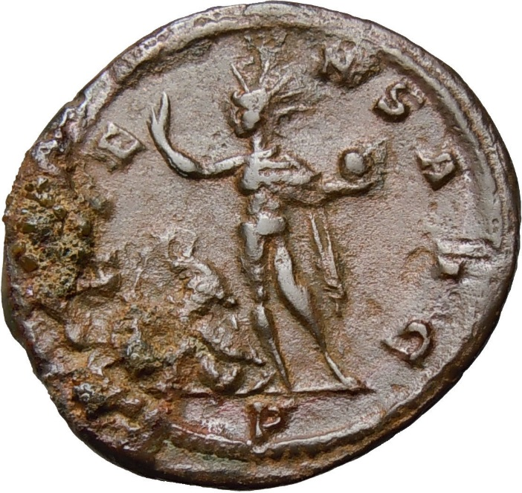

**Aurelian - Roman Emperor: 270-275 AD. - AE Antoninianus**  
Obverse: IMP AVRELIANVS AVG, radiate, cuirassed bust right    
Reverse: ORIENS AVG, Sol standing right, head turned left, holding globe and raising right hand, captive to left, P in exergue   
Weight: 3.2 g   
Diameter: 24 mm

Reference : Sear5 11564v